Implement Collection Framework interfaces such as List, ArrayList, Set, Map,
HashTable, and HashMap

Name: Thirupugazh.S.R
Reg no:-192371016.
Course Code: CSA0904
Course name: programming In Java

- import java.util.Scanner;
public class ATMPinValidator {
public static void main(String[] args) {
Scanner sc = new Scanner(System.in);

System.out.print("Enter ATM PIN: ");
String pin = sc.nextLine().trim();

System.out.println("PIN Length: " + pin.length());

if (pin.matches("\\d{4}")) {
System.out.println("Valid PIN");
} else {
System.out.println("Invalid PIN");
}
}
}

Output:
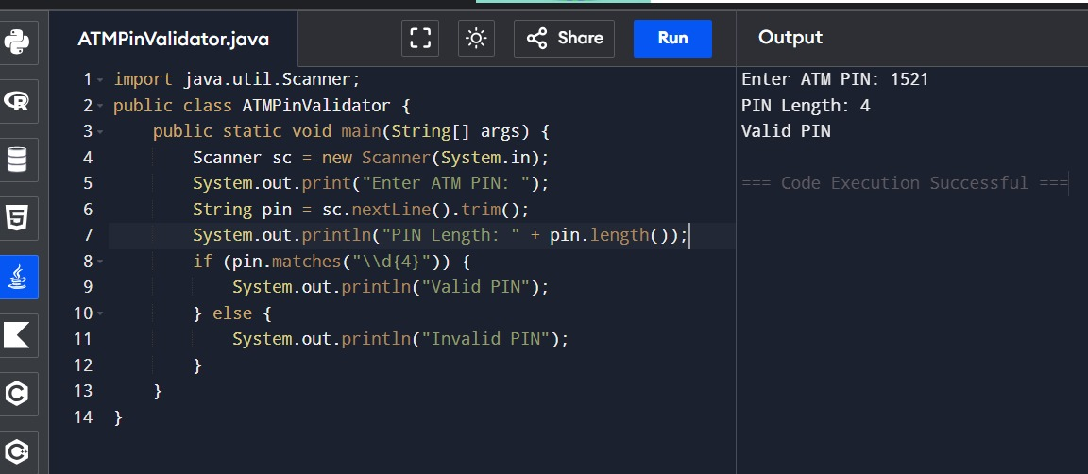
2)
import java.util.Scanner;

public class EmployeeID {
public static void main(String[] args) {
Scanner sc = new Scanner(System.in);

System.out.print("Enter Employee ID: ");
String id = sc.nextLine().trim();

String prefix = id.replaceAll("[0-9]", "").toUpperCase();
String number = id.replaceAll("[A-Za-z]", "");

System.out.println("Normalized ID: " + prefix.concat(number));
}
}
Output:

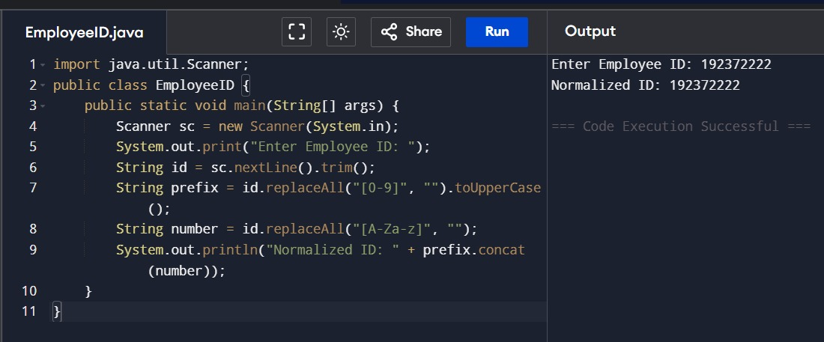
3)
import java.util.Scanner;

public class CouponCheck {
public static void main(String[] args) {
Scanner sc = new Scanner(System.in);

String coupon = "SAVE50";

System.out.print("Enter Coupon: ");
String input = sc.nextLine().trim().toUpperCase();

if (coupon.equalsIgnoreCase(input))
System.out.println("Coupon Accepted");
else
System.out.println("Invalid Coupon");
}
}
Output:

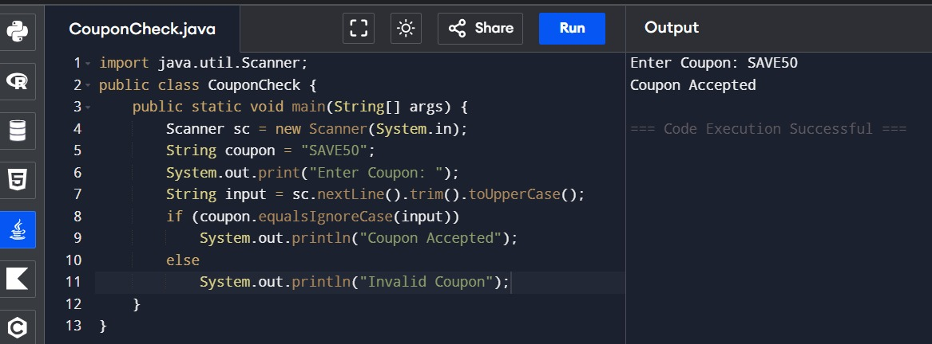
4)
import java.util.Scanner;

public class EmailExtractor {
public static void main(String[] args) {
Scanner sc = new Scanner(System.in);

System.out.print("Enter Email: ");
String email = sc.nextLine();

int pos = email.indexOf('@');
String username = email.substring(0, pos);

System.out.println("Username: " + username);
System.out.println("Length: " + username.length());
}
}
Output:

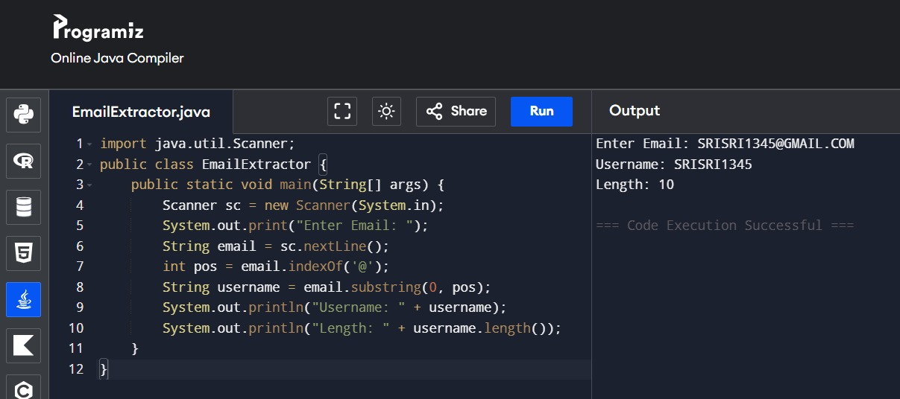
5)
public class RestaurantOrder {
public static void main(String[] args) {

String order = "DOSA-3-IDLY-2-VADA-1";

String[] items = order.split("-");

int count = 0;

for (int i = 0; i < items.length; i += 2) {
System.out.println(items[i].toUpperCase() + " : " + items[i + 1]);
count++;
}

System.out.println("Total Items: " + count);
}
}
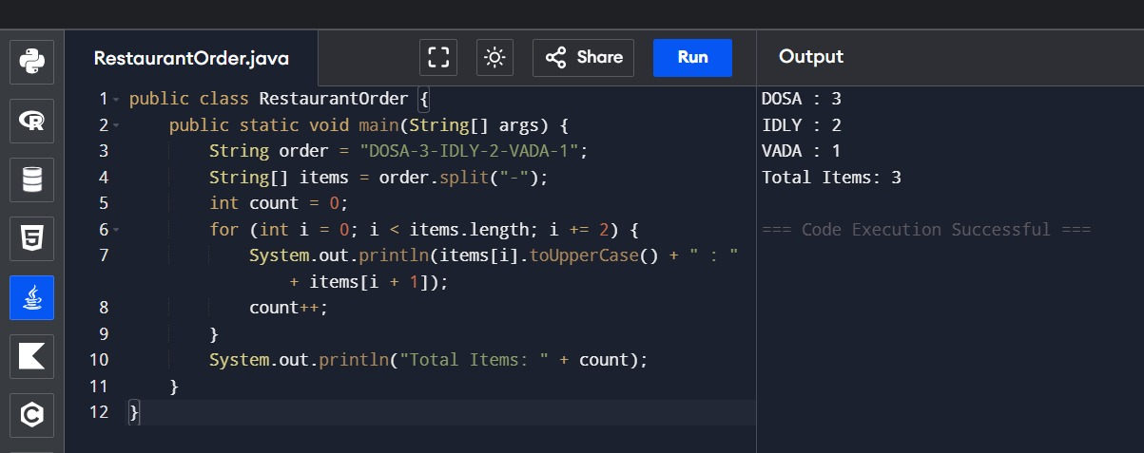
Output:

6)
public class RailwayTicket {
public static void main(String[] args) {

String ticket = "S5-43";

String[] data = ticket.split("-");

String coach = data[0];

System.out.println("Coach Number: " + coach.substring(1));
System.out.println("Coach Type: " + coach.charAt(0));
System.out.println("Seat Number: " + data[1]);
}
}

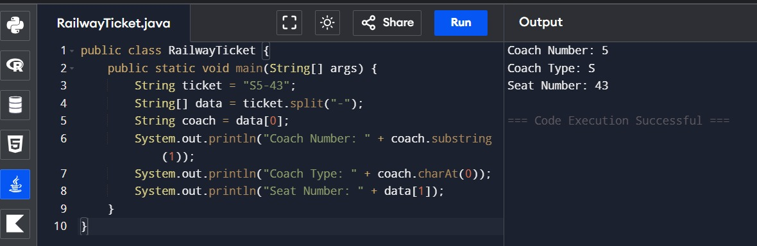
Output:

7)
import java.util.Scanner;
public class ProductSearch {
public static void main(String[] args) {
Scanner sc = new Scanner(System.in);
String product = "Milk";
System.out.print("Enter Product: ");
String input = sc.nextLine().toLowerCase();
System.out.println(product.toLowerCase().contains(input));
if(product.equalsIgnoreCase(input))
System.out.println("Exact Match");
else
System.out.println("Not Exact");
}
}

Output:

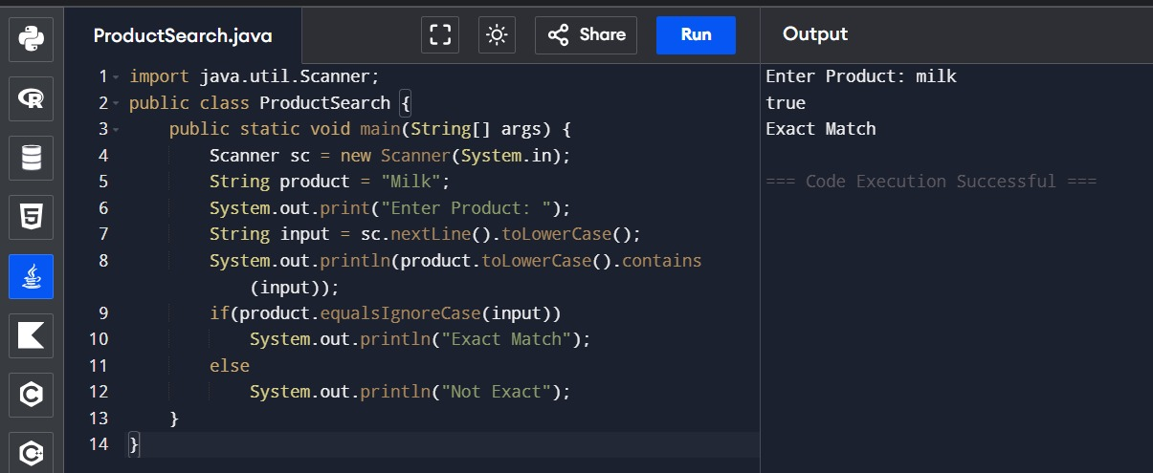

8)
import java.util.*;
public class ShoppingCart {
public static void main(String[] args) {

ArrayList<String> cart = new ArrayList<>();
cart.add("Rice");
cart.add("Milk");
cart.add("Sugar");

cart.remove("Milk");

System.out.println(cart.contains("Rice"));

System.out.println("Products: " + cart);

System.out.println("Total Products: " + cart.size());
}
}
Output:

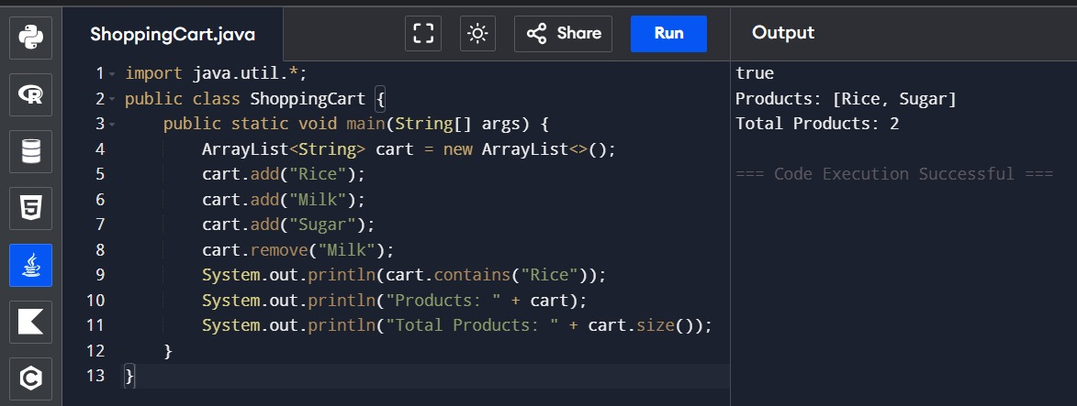
9)
import java.util.*;

public class BankQueue {
public static void main(String[] args) {

Queue<Integer> queue = new LinkedList<>();

queue.offer(101);
queue.offer(102);
queue.offer(103);
System.out.println("Served: " + queue.poll());
System.out.println("Next: " + queue.peek());

System.out.println(queue);
}
}
Output:

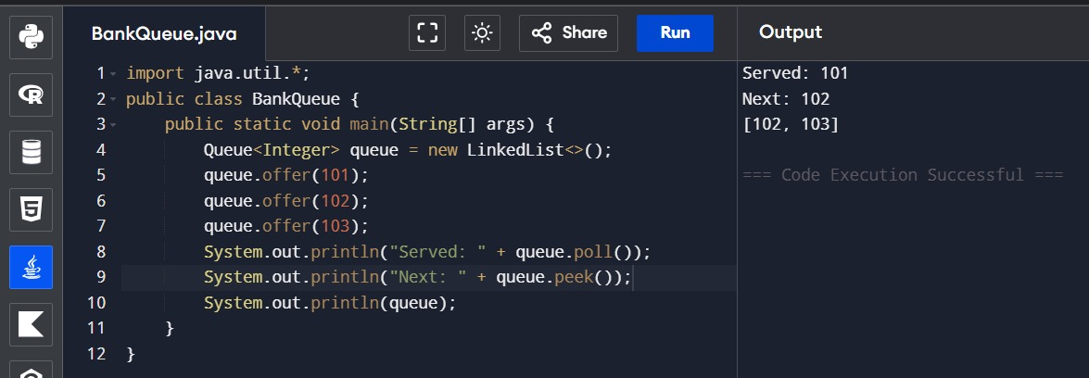
10)
import java.util.*;

public class ParcelTracking {
public static void main(String[] args) {

Stack<String> stack = new Stack<>();
HashMap<String,String> map = new HashMap<>();
stack.push("P101");
stack.push("P102");
map.put("P101","Chennai");
map.put("P102","Bangalore");

String parcel = stack.pop();

System.out.println("Unloaded Parcel: " + parcel);
System.out.println("Destination: " + map.get(parcel));
}
}
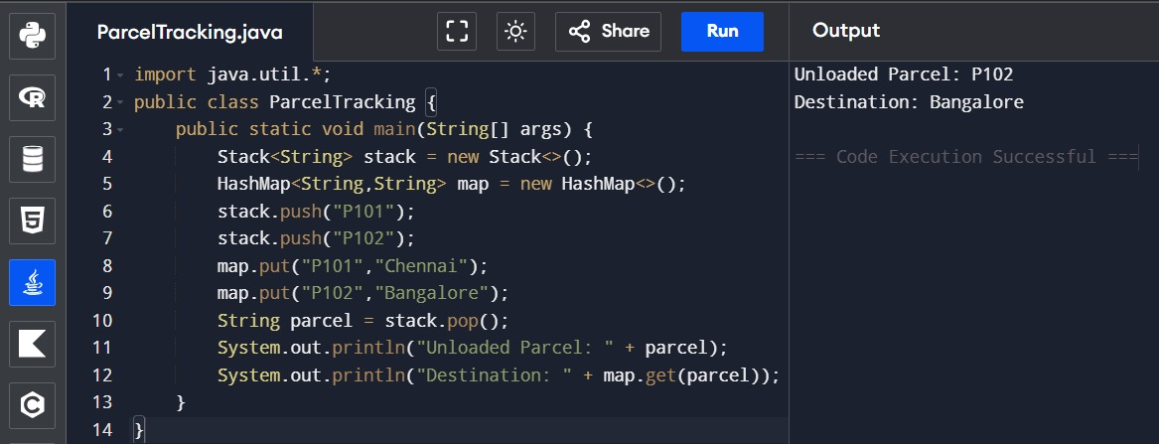
Output:

11)
import java.util.*;

public class HospitalAppointment {
public static void main(String[] args) {

Queue<Integer> queue = new LinkedList<>();
HashMap<Integer,String> patient = new HashMap<>();

queue.offer(1);
queue.offer(2);

patient.put(1,"Arun");
patient.put(2,"Kiran");

int token = queue.poll();

System.out.println("Served Token: " + token);
System.out.println("Patient: " + patient.get(token));
}
}

Output:

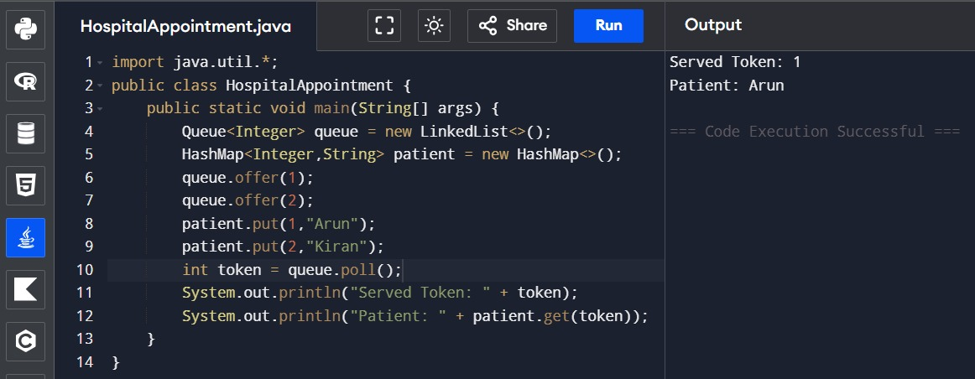
12)
import java.util.*;

public class CourseEnrollment {
public static void main(String[] args) {

ArrayList<String> students = new ArrayList<>();

students.add("Arun");
students.add("Kiran");
students.add("Rahul");

Iterator<String> it = students.iterator();

while(it.hasNext()) {
if(it.next().equals("Kiran"))
it.remove();
}

System.out.println(students);
}
}

Output:
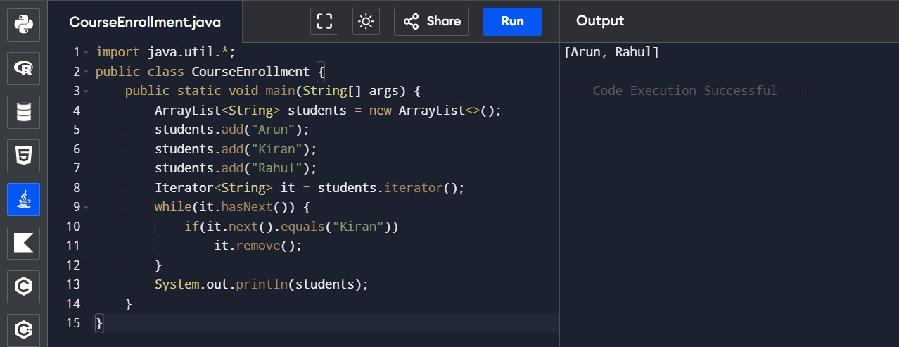

13)
import java.util.*;

public class Warehouse {
public static void main(String[] args) {

ArrayList<String> items = new ArrayList<>();

items.add("Rice");
items.add("Damaged");
items.add("Sugar");

Iterator<String> it = items.iterator();

while(it.hasNext()) {
if(it.next().equals("Damaged"))
it.remove();
}

System.out.println(items);
}
}
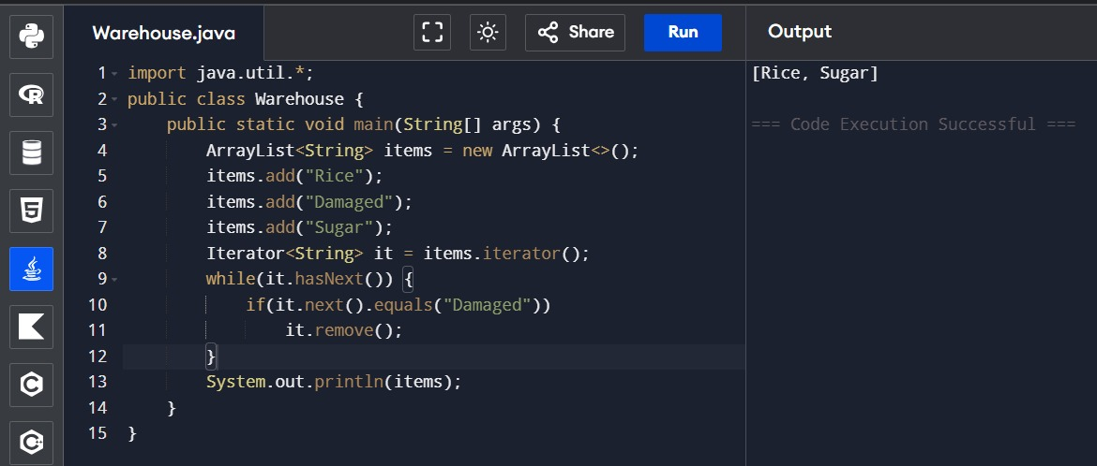
Output:

14)
import java.util.*;

public class BankToken {
public static void main(String[] args) {

Queue<Integer> queue = new LinkedList<>();

queue.offer(11);
queue.offer(12);
queue.offer(13);

System.out.println("Served: " + queue.poll());

System.out.println("Next Customer: " + queue.peek());

System.out.println("Remaining Queue: " + queue);
}
}
Output:

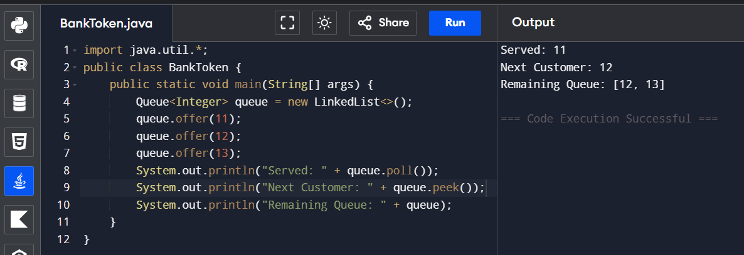

15)
import java.util.*;

public class BrowserHistory {
public static void main(String[] args) {

Stack<String> pages = new Stack<>();

pages.push("google.com");
pages.push("youtube.com");
pages.push("github.com");

System.out.println("Back: " + pages.pop());

System.out.println("Current Page: " + pages.peek());

System.out.println(pages);
}
}
Output:
